Shree Swanra Integrated Community Development Centre (SSICDC), Gorkha
Organization Profile

Brief introduction of organization

Background:

Shree Swanra Integrated Community Development Center (SSICDC) Gorkha is a non-political, non-governmental and non-profit making organization established by young and energetic youths in 1987 AD. The Organization has been working continuously since its establishment with the poorest and downtrodden people who are typically the social outcaste, women, children and the disadvantaged group, in general, of different castes and races.
The overall programs coverage of the organization are Community Health and Sanitation education, Maternal and Child Health Mobile clinic in coordination with DPHO(District Public Health Office), Sub-Health post, Health Post, conflict transformation and peace building, quality education, drinking water supply and sanitation, Informal adult and child education, women empowerment, micro finance, farmers managed irrigation, income generation through agriculture and forest resource management, community managed infrastructures like wooden bridge building, child development, reproductive health, child and women rights, Gender issues and social inclusion.
It is one of the local levels leading NGO that has adopted participatory approaches in working with the marginalized families and communities in delivering developmental program in 56 Village Development Committees (VDCs) of Gorkha district. It has the privilege of being a community based, locally recognized for its goodwill and the image within the community.

Presently the organization has an executive committee of 7 members and 86 general members in the most inclusive basis. The organization has conducted its 32 glorious general assembly in this year 2076 B.S.

The organization has accomplished the projects - Health and Sanitation Education, toilet construction, MCH mobile clinic in 25 VDCs, Integrated Community Development Program at 8 VDCs, HIV/AIDS Control Program on 24 VDCs and one Gorkha Municipality, Dhaka Knitting Training to Swanra VDC, Non-formal education to 10 VDCs, Rural water Supply and Sanitation Program in 19 VDCs and Gorkha Municipality directly benefiting more than 130000 people of the Gorkha District, Community Based Water Supply and Sanitation Program in Dolpa District, Decentralized Rural Infrastructure and Livelihood Project (DRILP) in association with consultants in Gorkha, Local Governance and Community Development Program (LGCDP) under DDC and Gorkha Municipality in Gorkha and HIV/AIDS Comprehensive program to migrants and their spouses in partnership with Save the Children International funded by Global Fund (SSF) Round-10 in Gorkha, Hariyo Ban Program with the partnership of CARE Nepal & WWF Nepal funded by USAID, Hariyo Ban Program/ Windows of Opportunity with the partnership of WWF Nepal funded by USAID, Improve Cooking Stove Program with the partnership of DDC Gorkha/ AEPC, Sakeshar Nepal Aviyan under District Education Office, Gorkha, Youth Partnership Program under DDC, Gorkha, Emergency Response, Reconstruction, Recovery and Resilience Programs with the partnership with CARE Nepal, Save the Children, WWF Nepal, UNDP, UNICEF, UNFPA, CRS, PAF, JSDF, Raleigh International, Lutheran World Relief and Poverty Alleviation Fund Program.

Currently the organization has been implementing Hariyo Ban Program with the partnership of WWF Nepal funded by USAID, WASH activities, Food Security and Livelihood, PRAYASH – II, DRR and safe Justice project with the partnership of CARE Nepal funded by different donors, Earthquake Reconstruction and Resilience Project- Phase –I & II with the partnership of CRS, Socio-Technical Facilitation Service for Housing Reconstruction Program In Gorkha with partnership of ODRC & UNDP funded by Government of INDIA.
Name of the Organization:
Shree Swanra Integrated Community Development Centre (SSICDC), Gorkha
- Date of establishment: 17th September 1987
- Registration
District Administrative Office (D.A.O.), Gorkha
Regd. No. 132
Date: 2nd March 1994
Latest Renewal Date: 2076/06/28 B.S.
Social Welfare Council (SWC) Regd No.: 1863
Date: 26th September 1994

- Working district: Gorkha, Dolpa and Lamjung.
- Contract Person: Sita Ram Shrestha (Educative Director),Contract No: 9841683867
Email:-shresthasitaram5@yahoo.com
- Membership: General Member: 86
Executive Member: 7
- Address: Gorkha Municipality-8, Haramtari, Gorkha (Head Office)
Phone: 064-421377/ 064-421162
Fax No. 064-420563
Email – gorkhassicdc@gmail.com
Web: -www.ssicdc.org.np
- PAN/VAT No.: 302174593

- Vision, Mission, Goals and Objectives of organization:

  - Vision of Organization:

SSICDC’s vision of the future is a society where people’s rights are fully respected with opportunities to lead a productive, happy and dignified human life irrespective of their religion, sex & caste and material condition.

  - Mission of Organization:

SSICDC works to encourage people’s participation in development process through capacity building of the communities. It supports local initiative to create a better future of the rural backward communities. This will be attempted through strengthening the civil society, especially the users groups complementing the local government efforts.

  - Goals of Organization:

The overall goal of SSICDC is to contribute meaningfully to improve the quality of life of rural backward communities of Nepal.

  - Objectives of the Organization:

The main objectives of the organization are to:

- Conduct Child Rights and Development Programs.
- Conduct women empowerment programs.
- Sustainable agriculture development.
- Lunch programs in human rights and social inclusion.
- Deliver sustainable health and hygiene benefits to the rural people through the provision of safe Drinking water interlinked with low cost sanitation and health education.
- Improve rural Infrastructure facilities like foot trails, trail bridges, micro irrigation, micro hydropower, community buildings and rural roads etc.
- Promote saving and credit & Co-operative.
- Develop and promote appropriate technologies in rural area.
- Develop, disseminate and promote renewable energy technologies in rural area.
- Conserve environment and natural resources & encourage its sustainable use.
Create and Prepare good learning environment for quality inclusive education.
- Create the employment opportunities through various income generating and vocational training.
- Organize the awareness program and other different social, economic and educational programs for the upliftment of marginalized group.
- Conduct the programs for the improvement of livelihood focused on tourism, livestock and
medicinal herbs.

Description |  |  | Dalit |  | Janjati |  | Other |  | Total
 |  |  | M | F | M | F | M | F | M | F
General Members |  |  |  |  |  |  |  |  | 36 | 50
Executive Board
S.N | Name | Position
1. | Krishna Kumari Gurung | Chair person |  |  |  | 1
2. | Shankar Nepali | Vic-Chair Person | 1
3. | Devi Maya Thapamagar | Treasurer |  |  |  | 1
4. | Yam Narayan Shrestha | Member |  |  | 1
5. | Gyan Maya Gurung | Member |  |  |  | 1
6. | Tulasi Babu Shrestha | Member |  |  | 1
7. | Hariman Gurung | Secretary |  |  | 1
- Executive Board Profile:

4. Experiences of Organization:
The following depicts the experiences of organization shortly:
Experiences
Name of Project | Integrated Community Development Program |  | Date from: 1988 A.D. |  |  |  | To: 1997 A.D.
Name of Donor | Save the Children US |  | Contact Person: |  | N/A
Description | 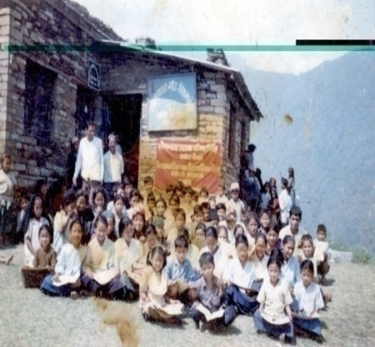  Major activities: Child Education, Adult Education, Scholarship for Students, Women Empowerment, Community Group Mobilization and Micro Credit Support, Income Generation Program, Agro Forestry, Saving and Credit, Goat Raising, Poultry Farming, MCH Clinic, Health Camp, Sponsor Child Health Camp, family planning, School Building Construction, Irrigation, Wooden Bridge Building, Vegetable Farming, Pig Raising and Child survival project, CHV and VHP Training, First Aid Training and kit Box distribution to school Teachers, Safe Motherhood Program, Nutrition and Immunization Program for Under 5 children, School Health Education program, Sponsor children Health check camp etc.  Child Education at NGO Office, Swanra VDC Gorkha
Name of Project | HIV/AIDS Control Program | Date from: 2001 A.D. |  |  |  | To: 2003 A.D.
Name of Donor | SNV/DGIS | Contact Person: |  | N/A
Description | Major activities:  Peer Educator Counseling Training, Video Show, Puppet Show, Street Drama show, World NAids Day and Condom day Celebration, Game, Essay, Speech Competition, IEC Material distribution, Workshop, Rally, Condom distribution, SAFALTAM Income Generation Program, and Hoarding Board display etc.  Awareness raising workshop on HIV/AIDS  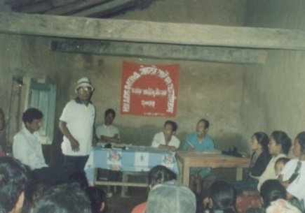

Name of Project | Rural Water Supply and Sanitation Project Gorkha. (RWSSFDB) | Date from: March 1998 |  | To: Dec. 2011
Name of Donor | Fund Board/ World Bank | Contact Person: | Mr. RajuBabuShrestha
Description | Each Scheme Completed in 4 stages:  Feasibility Study: During the pre-feasibility basically two experts in the area of social science and engineering will engage. PRA, focused group discussion, site verification, interaction with various groups, social mobilization and technical verification are the major methodology applying in pre-feasibility study.  Development Phase: Community Mobilization, Institutional Development Activity and Socio- Economic Activity including Technical Support Which includes Formation and Registration of Water Users Group (WUG) under water resource act, Health and Sanitation Education (HSE), Mother Tap stand Group Formation, Promotion of Personal, Domestic and Environmental Hygiene, Preparation of Community Action Plan (CAP) from CAP Trainings, Mother and Child Health Education, Women Water Supply and Sanitation Implementation Plan, School Health Education Activities, WSUC/WUG, VMW, VHP, WTSS and WSUC Treasurer Trainings, Community Based Survey and Preparation social profile, design and estimate preparation, financial proposal preparation, O&M Fund (3%of total cost) and Upfront cost (2.5% of total hardware cost) collection,
Aware of collecting local material and kind contribution (30-40%). HHs and Institutional Latrine Construction.
Implementation Phase:Water Supply Scheme Construction, VHP, WTSS and WUC Treasurer Trainings, Carried out A1 to A14 Activities, Which are given below:
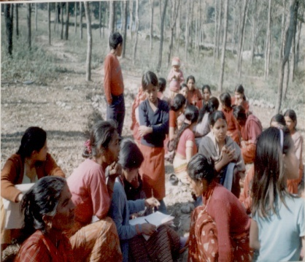
A1 - Scheme Layout and Construction, A2 - Sanitation Program/ Utilization of SRLF, A3- Health Education Support to Mother and Child Tap Stand Groups, A4 – Village Environment Hygiene Promotion, A5 – Women’s Technical Support Service, A6 – Non-Formal Education Activities, A7 – Water Source Protection, A8 - Local Material Collection, A9 – Community Cost Contribution, A10 – Community Procurement, A11 – Community Person Power, A12 – SOs Person Power, A13 – Operation and Maintenance, and A14 – Community Monitoring and Evaluation.
Mobilizing Women Saving & Credit Group at Aarughat
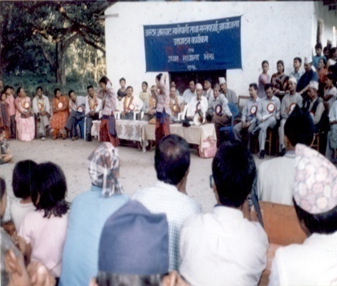
Post Implementation Phase; Providing WSUC Post construction training, Water Tariff collection, VMW Operation and Maintenance Training, regular meeting and minute of Women Group, WSUC, and Mother Tap stand Group, Teacher Student Health and Sanitation Group, Information dissemination. and celebration of World Water Day, Sanitation Week, regular fallow up on household toilet using, Hand washing practice, Declaration of Open Defecation Free Area, Proper account keeping and documentation support to WSUC.
Opening of Aarughat Water Supply Scheme at Aarughat

Name of Project | Decentralized Rural Infrastructure and Livelihood Program (DRILP) | Date from: April 2007 |  | To: Aug. 2011
Name of Donor | District Development Committee (DDC), Gorkha / ADB | Contact Person: | Mr. VijayaLal Nyachhyon
Description | 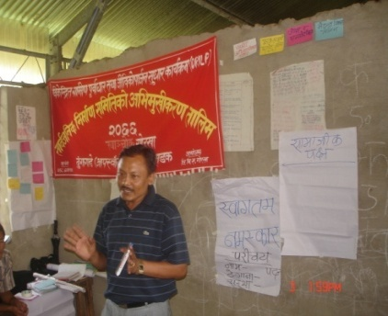  The Decentralized Rural Infrastructure and Livelihood Project (DRILP) is being implemented with the loan financing of ADB and additional grant of SDC. The loan agreement was signed by HMGN and ADB. The project implemented in 18 districts of Nepal that are among the poorest and conflict affected. DRILP is implemented using the approach of Labor based, Environmentally - friendly, Participatory (LEP). So that poor, marginalized, conflict affected, women and disadvantage & socially excluding group benefited from the project. Project provided new and rehabilitated rural roads and main walking trails to improve access to and from isolated, poor rural areas. SSICDC had associated with consultant for social mobilization works. The project rehabilitated Gorkha to Aarughat road 38.22 Km of Gorkha District.  Facilitated by Mr. Sita Ram Shrestha on VWRCC orientation at Baguwa  The cash for work activities have been accomplished in a large scale during the project through building groups
Major Activities: Social Mobilization, Walkover survey, Detail Engineering Survey , ZOI Survey, IEE Survey, Cadastral Survey, Baseline Survey, Formation of Village Works Road Construction Committee (VWRCC) & Grievance Redress Committee (GRC) of Seven VDCs & a Gorkha Municipality, Resettlement Plan Survey, Resettlement plan, Compensation Distribution, Outcome Monitoring Survey, Survey, Design, Estimate and Implementation of Supplementary Investment Schemes (SIS), as well as social mobilization for Deed Transfer, Grievance Readdress, Land Donation, Compensation determination and dissemination, Women Empowerment and given the high priority to severely affected, disadvantage, marginalized and poor people of the influence area.
Closing on Allo Purification Training at G.M. – 10, Terhakilo
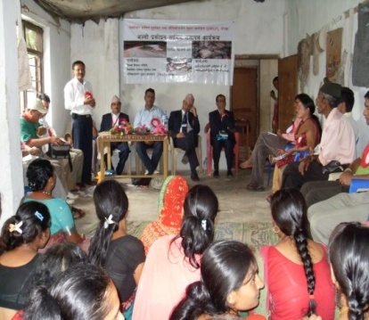
Trainings Conducted: Social Inclusion Training, Right Base Approach Training, PRA Training, Gender and women Empowerment Training, VWRCC Awareness Raising Training, Preventive Health and Sanitation Training, HIV/AIDS Awareness Raising Training, Sixteen number of life skill Trainings, Training on Safe Motherhood and Pre & Post Natal Care, Training on Conflict Transformation, Gender Mainstreaming Workshop Training, Building Group Orientation Training, Leadership Development Training, Child Rights & Development Training, Training on Transparency, Accountability and Governance, Public hearing, near about completion Upgrading or Graveling of the Dhungagade (Aanpswanra)- Aarughat Road (DAR) 38.22 km.
Name of Project | Community Based Water Supply and Sanitation Program (CBWSSP), Dolpa | Date From: 30 March 2008 |  | To: 30 Oct. 2011
Name of Donor | DDC, Dolpa / ADB | Contact Person | Mr. Mahendra Prasad Chaudhary
Description | 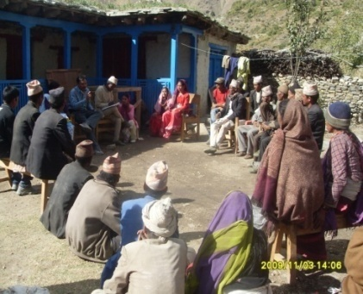  Government of Nepal with the financial assistance of Asian Development Bank (ADB) is implemented Community Based Water Supply and Sanitation Project (CBWSSP) during the period 2004-2011. The goal of the project is poverty alleviation through improved health and quality of life of the people living in the 1200 rural communities. The Ministry of Physical Planning and Works (MPPW) is the executing agency. Department of Water Supply and Sewerage (DWSS) are the implementing agency at the central level, and District Development Committee (DDC) at the district level. CBWSSP will have a district level Community Water Supply and Sanitation Unite Office under DDC in each project district.  This project is designed with a demand driven approach to respond to the user’ need for rural community based water supply and sanitation services. Community’s demand is most evidenced by willingness to pay for those services. This is why the project has aimed for greater community involvement in planning and implementation and full responsibilities of Operation & Maintenance (O&M) activities.  To ensure objectivity in prioritizing the water supply and sanitation sub-project, selection criteria will be established. The criteria should reflect socio-economic and health conditions, coverage of water supply and sanitation.  Consultation meeting at Ruma, Dolpa
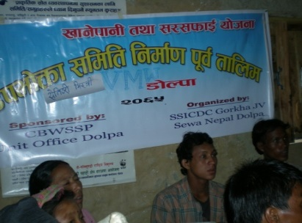
Facilities, poverty level, Gender. Caste and Ethnicity factors and community demand for improve water supply and sanitation services in the village.
The project will focus on the poor communities, where inadequate water supply and sanitation have adversely affected the health status and quality of life. The project objectives are to (i) improve water supply and sanitation facilities and provide a health and hygiene education program in each community, (ii) support community participation in the development of water supply and sanitation facilities, and (iii) conduct gender, cast and ethnic group development programs, empower them and launch income generation and educational activities.
Participants of User CommitteeTraining at Ruma, Dolpa
Planning Phase: Socio-economic Survey, data entry, Report Preparation, Base Line Survey, Poverty ranking, Gender cost and Ethnic group Orientation Training, Community Awareness Camping, Household Listing, Pre feasibility Study and Report Preparation, WSUC Orientation Training.
ODF declare program on Water Supply Scheme area at Dolpa
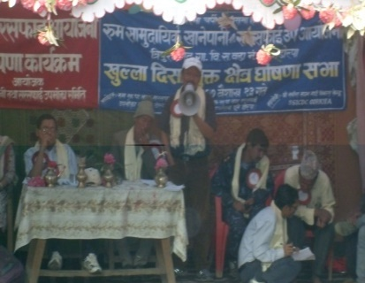
Development Phase: Training for Community Female Health Volunteer, Non formal education facilitator, School Teacher Students Group, WUSC pre construction Training, Sanitation Mason Training, Village Maintenance Worker Training, Promotion of Household Toilet, Personal, Household and environmental Sanitation, School Toilet Survey, Design, Estimate and Construction, Water Supply System Planning, Survey, Design, and approved by the community.
Implementation Phase: Help Community on Market Survey, Procurement of Non local Material, Water Supply System Construction, Completion of household Toilet construction, WSUC Account Training, Operation and Maintenance Training, Water Supply System Management Training, Health and hygiene education to mother tap stand group, report Preparation and Submission.
Post Implementation Phase: Monitor the States of Sanitation revolving lone fond, operation and maintenance fond collection, scheme functioning states, WSUC post construction training, village maintenance worker training, Open Deification Free Area Declaration, report prepare and Submission.
1. Ruma CBWSSP: Pipe Length 5.46 km, Tap Stand no. 8, BPT no. 1, IC no. 8, CC no. 1, Intake 1, RVT no. 2 and School Toilet 1.
2. Rasi CBWSSP: Pipe Length 4.35 km, Tap Stand no. 11, BPT no. 1, IC no.4, CC no. 1, Intake 1, RVT no. 2 and School Toilet 2.
3. Ranga CBWSSP: Pipe Length 3.62 km, Tap Stand no. 12, BPT no. 2, IC no.1, Intake 1, RVT no. 2 and School Toilet 1.
Name of Project | Local Governance and Community Development Program (LGCDP) - DDC, Gorkha | Date from: 13 Feb. 2011 |  | To: 15 July, 2011
Name of Donor | DDC, Gorkha / Development Partners | Contact Person: | Mr. Mahesh Baral
Description | 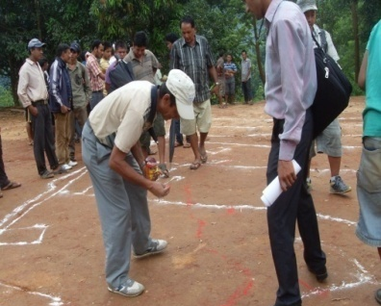  Government of Nepal lunched LGCDP program all over the country to bring tangible change in local governance and community development process. Taking the aims to improve the living standards of the people through community led development, efficient service delivery, good governance and right based approach. SSICDC Gorkha has implemented the LGCDP program in 9 VDCs of the Gorkha district with Livelihood Improvement Plan implementation in Prok and Bihi VDCs.  Social Mapping by Community at Ghyalchowk  Community Mobilization, Formation of Ward Citizen Forum and Citizen Awareness Center, Orientation on LGCDP to stakeholders, Well Being Ranking, Gender Analysis, Community Resource Mapping & DAG Mapping, Trainings Conducted - a. Community Mobilization, b. Reflect Training & c. Local Level Planning Training, conducting reflect class on CAC, Livelihood Improvement Plan (LIP) implementation in two CAC Prok and Bibi VDC.
Name of Project | Local Governance and Community Development Program (LGCDP) – Gorkha Municipality, Gorkha | Date from: Feb. 2012 |  | To: 15 July, 2012
Name of Donor | Gorkha Municipality, Gorkha/ Development Partners | Contact Person: | Mr. Ram Chandra Adhikari
Description | 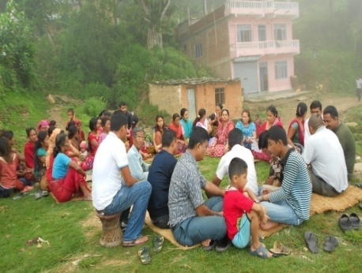  Government of Nepal lunched LGCDP program all over the country to bring tangible change in local governance and community development process. Taking the aims to improve the living standards of the people through community led development, efficient service delivery, good governance and right based approach. SSICDC Gorkha has implemented the LGCDP program in 4 wards of the Gorkha Municipality, Gorkha.  Community Mobilization, Formation of Ward Citizen Forum and Citizen Awareness Center, Orientation on LGCDP to stakeholders, Well Being Ranking, Gender Analysis, Community Resource Mapping & DAG Mapping, Trainings Conducted - a. Community Mobilization, b. Reflect Training & c. Local Level Planning Training, Reflect class for CAC, WCF & CAC observation visit etc.  Consultation meeting for CAC formation at Gorkha Municipality - 2
Name of Project | HIV/AIDS Comprehensive Program to migrant & their spouses. | Date from: April, 2012 |  | To: March, 2015
Name of Donor | Save the Children International / Global Fund | Contact Person: | Mr. David Wright
Description | 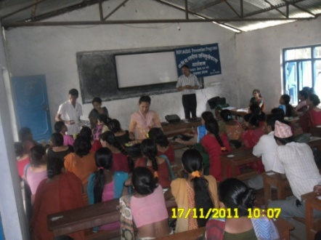  In Nepal, socio- economic and political factors are seen to be responsible for Inducing large scale migration abroad, particularly to India. People owning low productive land, from low economic brackets and who are directly or directly influenced by ongoing political conflict are particularly the ones who are likely to Migrate. A large number of men and women leave their households for seasonal or long-term labor migration to urban centers or to the Neighboring countries, in search of employment. There are an estimated 967,000 to 1,511,000 seasonal labor migrants in Nepal.So Government of Nepal lunched HIV/AIDS prevention program in Nepal from the support of Global Fund. SSICDC Gorkha implements the program in Gorkha District.  VDC level orientation by PC, Sita Ram Shrestha at Palungtar  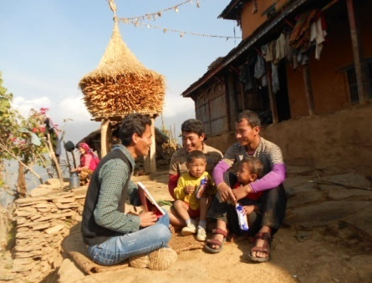  Community Mobilization, various type of orientation for different level, Orientation to School Students on Safer Sex behaviors and HIV/ AIDS control, Peer educator selection, VDC mapping, planning, review & reflection meeting, supervision, data verification, Reporting by Online Program Management Information System (OPMIS), recording, documentation, Monthly, quarterly & Annual Report preparation and submit, provide outreach education to target group, day celebration (world AIDS day, Condom day, Candle light day), street drama show, conduct District AIDS Coordination Committee & stakeholders meeting, program joint monitoring visit, coordination with stakeholders/ line agencies, provide Integrated Health Center services, video show, refer to STI/VCT/PMTCT/CD4/ARV, Support to PLHA through Community Based Home Care service, nutrition support to PLHA, Cass support to Child who is PLHA, media mobilization etc.  To provide BCC education by OW, Arjun Kumar Tamang

Name of Project | Hariyo Ban Program | Date from: June, 2013 |  | To: July, 2016
Name of Donor | WWF Nepal & CARE Nepal funded by USAID | Contact Person: | Mr. Anil Manandhar
Description | The Hariyo Ban Program, funded by USAID and implemented by a consortium of WWF, CARE, NTNC and FECOFUN with WWF as the lead, aims to reduce adverse impacts of climate change and threats to biodiversity in Nepal. It works on three core interwoven components - biodiversity conservation, sustainable landscapes and climate change adaptation with livelihoods, gender and social inclusion being important cross cutting themes. Hariyo Ban Program is being implemented in two landscapes of Nepal - Terai Arc Landscapes (TAL) and Chitwan-Annapurna Landscape (CHAL), complemented by enabling policy support at the national level. SSICDC Gorkha implemented the program in Gorkha district from June 2013 to till date in partnership with WWF Nepal and CARE Nepal. Through this program SSICDC Gorkha support 27 school of Daraundi Watershed to formation ECO Club and support them for office established furniture, stationary, learning materials, conduct orientation on Climate Change adaptation, mitigation and biodiversity conservation. Train teachers on quality learning environment in School. Support for WASH facility in all 27 school for clean and safe drinking water with adequate toilet building and its proper use.
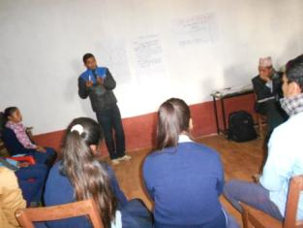
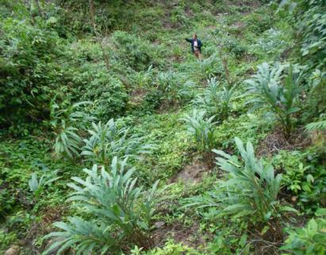
Community/CFUG Mobilization, various type of orientation for different level, consultation meetings, need assessment, Income generation fund mobilization through Cooperatives, VDC mapping, planning, participation & conduct review & reflection meeting, supervision, data verification, Reporting by Online data based reporting, recording, documentation, weekly update progress, Monthly, quarterly & Annual Report preparation and submit, day celebration (world environment day etc.), program joint monitoring visit, coordination with stakeholders/ line agencies, media mobilization, Climate Change Adaptation Plan for Action (CAPA) implementation, Plantation, conduct biodiversity conservation & good governance workshop, Pig rearing orientation, mushroom cultivation training, bee keeping training, Eco Club formation and mobilization, Community Based Anti-Pouching Unit formation (CBAPOU), provide training, materials support and mobilization, Public Hearing and Public Auditing, Gender Responsive Budget Analysis of Local Body, Well Being Ranking of CFUG, Participatory Good governance Assessment, Installed Metallic/ Improve Cooking Stove (M/ICS), Plantation support to Community Forest User Groups, fruit cultivation support, fodder plantation support, broom grass cultivation support, Cardamom cultivation support, fish farming support, poultry farming support, vegetable cultivation support, green house tunnel support, plastic pond support, water resource management support, land slide management support, chiraito cultivation support, green enterprise development support, landslide management support, bee with hive support, doom house support for mushroom cultivation, revolving fund mobilization support to Income Generation Activities, Livelihood Improvement Plan prepare and implementation support, Irrigation canal maintenance support, Support Lifting and Gravity Drinking water Supply Scheme, Institutional strengthening support to CFUGs and Cooperatives etc.
Eco Club orientation by F.S, Narayan Dhakal at BindhaBasini HSS, Nareswor
Cardamom cultivation at mausulipakha CFUG, Simjung - 9

Name of Project | Youth Partnership Program | Date from: F.Y. 2069/070 & 2070/071 B.S. |  | To: FY.2069/070 & 2070/071 B.S.
Name of Donor | DDC, Gorkha | Contact Person: | Mr. Krishna BahadurKarki
Description | Government of Nepal lunched the Youth Partnership Program expecting to generate Self-employment and SSICDC Gorkha implement the program in Gorkha with the support of DDC, Gorkha.  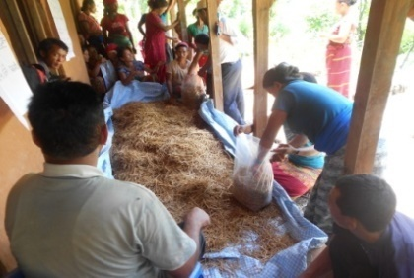  VDC level consultation meeting, community level consultation meeting, coordination with stakeholders/ line agencies, Mushroom cultivation training and spun (seed) & plastic support, supervision and follow up etc.  Participants of Mushroom cultivation training at Tanglichowk

Name of Project | Improved Cooking Stove (ICS) Program | Date from: April 2014 |  | To: June 2015
Name of Donor | DDC, Gorkha/ AEPC | Contact Person: | Kul Raj Chalise
Description | Government of Nepal has implemented the ICS Program through its executing body AEPC all over the country and by DDC in each district through a partner DSC. SSICDC Gorkha has selected as DSC in Gorkha to implement the ICS program and implemented from Baishakha 2071 BS.  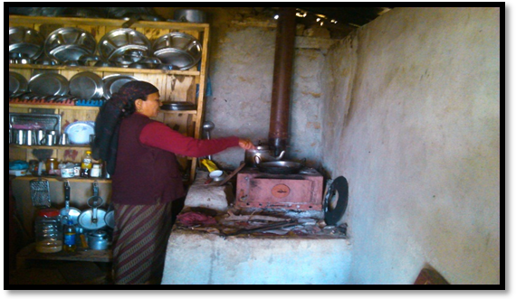  All the part of social mobilization, VDC level Orientation & consultation meeting, community level consultation meeting, coordination with stakeholders/ line agencies, VDC level Action Committee formation, selection of business groups, Mother group orientation for Behavior Change Communication, training of stove master/business groups, opening joint bank account of business group & staff, motivation, Indoor Air Pollution Free declare Community/VDC, supervision & monitoring, planning, reporting, recoding and documentation etc.  Using MICS by GhamraniGhale at Barpak
Name of Project | Sakshar Nepal Aviyan | Date from: March 2014 |  | To: Dec. 2014
Name of Donor | District Education Office, Gorkha | Contact Person: | Thakurji Tiwari
Description | According to the plan and promise of GoN to declare Nepal as Literate Nepal by 2015 DEO Gorkha lunched literate Gorkha campaign and SSICDC Gorkha has also lunched the program in Aaruchanaute, Namjung and Saurpani VDCs of Gorkha District in partnership with DEO Gorkha.  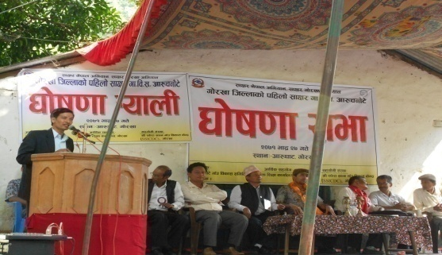  All the part of social mobilization, VDC level Orientation & consultation meeting, community level consultation meeting, coordination with stakeholders/ line agencies, selection of sakesharata volunteer, mobilized sakesharata class, supervision & monitoring, planning, reporting, recoding and documentation, illiterate free declare VDC etc.  First Literate VDC Aaruchanaute declare Programof Gorkha district at Aarughat

Name of Project | Emergency Response and Recovery Program | Date from: May 2015 |  | To: Till date
Name of Donor | CARE Nepal | Contact Person: | Mr.Jean-Dominique Bodard
Description | Project Area:  The project has covered 15 VDCs of Gorkha district mainly covering northern part of the district.  Major activities coverage:  After the devastating earthquake, the community people have suffered from a number of problems and SSICDC assured to conduct the following tasks during the contact tenure:  - Temporary shelter support (tarpaulin, CGI sheet or cash equivalent to CGI sheet, fixing tools, agriculture commodities, Winterization).  - Psychosocial counseling to earthquake victims, support them.  - Toilet maintenance and construction, 1200 HHs latrine reconstruction.  - Water supply and sanitation reconstruction 31 scheme.  - Hygiene promotion WASH activities in the community level  - FSL (Food security and livelihood) related activities.  - Agriculture seeds, irrigation cannel and plastic tunnel support  - Maintain FFS (Female Friendly Space) to support the pregnant women during delivery.  - Conduct Cash for Work activities.  - Health Post and ORC/PHC building Cons.  - Mason Training for Build Back Better and Safer reconstruction  - Door to Door visit for Disseminate 10 key message and technical support  - Media mobilization for build back better.  - Street drama show and focus group discussion.  - Collection centre construction  - School WASH recovery 22 School

Name of Project | Emergency Response and recovery Program | Date from: June 2015 |  | To: Till date
Name of Donor | Save the Children International | Contact Peson: | Mr. DhurbaDevkota
Description | Working Area:  The project has covered 8 VDCs, i.e. Swanra, Takukot, Pandrung, Masel, Deurali and Barpak, Tandrang, Aruchanaute and Nareswor..  Major Activities Coverage:  Following are the major activities associated with Save the Children International currently :  - Temporary shelter support (tarpaulin, CGI sheet or cash equivalent to CGI sheet)  - TLC (Temporary Learning Center) Construction 114 School TLC.  - 450 HH supported Nrs 340000.00 for permanent shelter construction and Toilet maintenance and construction.  - Water supply and sanitation scheme 21 Schemes.  - Hygiene promotion WASH related activities in the community level  - Training conduction to teachers on Education on Emergency  - ECD kits and educational materials distribution to schools.  - FSL (Food security and livelihood) related activities.  - Promotion for small entrepreneurs in the community level under market recovery project  - Child protection activities, established endowment fund 8 VDCs Rs 725000 per VDC .  - Psychosocial counseling to earthquake affected people and Children.  - Mason Training in 6 VDCs 200 person  - Door to Door visit to Disseminate 10 key message for Build Back Better and Safer reconstruction.  - Media Mobilization for Safer Shelter Reconstruction 10 key message disseminate and technical support.  - Street Drama and focus group discussion for community awareness  - Support to prepare LDRMP for 6 VDCs  - Skilled Masson training 7 days and unskilled mason training 50 days  - Build the Demonstration Building 6 nos.  - DRR plan prepare and implementation of 42 school of 6 VDCs  - 8 Health Post Building and 11 ORC/PHC Building Construction  - 8 School Building 64 classroom constructed  - Child Friendly Space construction  - Micro enterprise established 17 enterprise  - Support for disable friendly construction in school, health post, community building.  - Door to Door technical support for build back better, safer and greener  - Collection Center construction  - School WASH Recovery 36 Schools  - Health, Nutrition and SRMH program

Name of Project | Earthquake Response Recovery Gorkha | Date from: June 2015 |  | To: Till date
Name of Donor | Lutheran World Relief(LWR) | Contact Person: | Mr. Michael Watt
Description | Working Area: Jaubari VDC and Muchok VDC  Activities Coverage:  The following illustrates the short description of project activities:  - Temporary shelter support (tarpaulin, CGI sheet or cash equivalent to CGI sheet, fixing tools).  - Food items and non food item support  - Live-stock and agriculture support with varieties of training  - Cash for Work activities  - Mason training for earthquake resilient building construction  - Prepare DRR plan in the project VDC  - Permanent building construction Support for 100 HHs NRs 200000.00 per HHS up to second tranchi.  - Door to Door assistant for Build Back Better and safer  - Media Mobilization for Build Back Better and safer  - Climate Smart Agriculture support  - Toilet construction support and  - WASH and irrigation cannel reconstruction support  - Support for LDRMP preparation of the VDC  - Collection centre construction  - Livestock recovery

Name of Project | Poverty Alleviation Program/ JSDF project | Date from: May 2015 |  | To: June 2018
Name of Donor | Poverty Alleviation Fund (PAF) | Contact Person: | Mr. Bipin Dhital
Description | Working Area: Kasigaun, Manbu,Thumi and Aruarbang  Activities Coverage:  The following illustrates the short description of project activities:  - Need Assessment and identification of Poverty  - Food Security, Value chain strengthening, Livelihood Support, Agriculture Infrastructure support, Social inclusion, Cooperative, Social Mobilization, Income generation Activity. Develop Agriculture Paket area.  - Masson Training in 4 VDC 200 person.  - Small infrastructure development Irrigation, community building, foot trail improvement, wooden bridge etc.  - IGA program for poor and vulnerable group.

Name of Project | LSER Program | Date from: April 2016 |  | To: October 2016
Name of Donor | UNDP | Contact Person: | Mr. Kisor Karna
Description | Working Area: Gorkha Municipality, Barpak, Jaubari, Gumda, Harmi, Aappipal,  Activities Coverage:  The following illustrates the short description of project activities:  - Need Assessment and identification of Poverty  - Food Security, Value chain strengthening, Livelihood Support, Agriculture Infrastructure support, Social inclusion, Cooperative, Social Mobilization, Income generation Activity. Develop Agriculture Paket area.  - Enterprise Recovery Assessment  - Small infrastructure development Irrigation, community building, foot trail improvement, wooden bridge etc.  - Enterprise Recovery.  - Enterprise Development Training(SIYB) technology handover.  - Support for Entrepreneurship Development and Recovery.
Name of Project | CILRP Program 1 | Date from: December 2016 |  | To: August 2017
Name of Donor | UNDP | Contact Person: | Mr. Suman Manandhar
Description | Working Area: Kharibot, Ghyachok, Swanra, Saurpani, Takukot and Tandrang.  Activities Coverage:  The following illustrates the short description of project activities:  - Need Assessment and identification of Poverty  - Food Security, Value chain strengthening, Livelihood Support, Agriculture Infrastructure support, Social inclusion, Cooperative, Social Mobilization, Income generation Activity. Develop Agriculture Paket area.  - Community Infrastructure Damage assessment  - Small infrastructure development Irrigation, community building, foot trail improvement, wooden bridge etc.  - Support for community infrastructure reconstruction and livelihood promotion.
Name of Project | CILRP Program II | Date from: 20 Nov 2017 |  | To: 20 Apr 2018
Name of Donor | UNDP | Contact Person: | Mr. Niranjan Tamrakar
Description | Working Area: Ajirlot Rural Municipality and Gorkha Municipality,  Activities Coverage:  The following illustrates the short description of project activities:  - 15 Community Infrastructure Rehabilitation and 7 Rural Livelihood activities.

Name of Project | Emergency Response for Sexual and Reproductive Health Gorkha 1 | Date from: 1May 2015 |  | To: 15 Dec 2015
Name of Donor | UNFPA | Contact Person: | Mr. Dipendra Panta
Description | Working Area:, Barpak, Laprak, Gumda, Saurpani, Simjung, Arughat, Deurali and Dhuwakot.  Activities Coverage:  The following illustrates the short description of project activities:  - Established Female Friendly Space and provide service from there  - Established Transit Home and provide Service  - Established Child Friendly Centre and service  - Counseling Service and ANC, PNC Service for pregnant and GBV survivor  - Distribute Dignity Kids and referral services  - Provide transitional Shelter and logistic support for pregnant, Delivery women.  - Conduct SRMH Mobile Clinic in Different part of Gorkha  - Conduct RRT ToT for Health service provider

Name of Project | Emergency Response for Sexual and Reproductive Health Gorkha 11 | Date from: 1 January 2016 |  | To: June 2017
Name of Donor | UNFPA | Contact Person: | Mr.
Description | Working Area:, Barpak, Laprak, Gumda, Saurpani, Simjung, Arughat, Deurali and Dhuwakot.  Activities Coverage:  The following illustrates the short description of project activities:  - Established Female Friendly Space and provide service from there  - Established Transit Home and provide Service  - Established Child Friendly Centre and service  - Counseling Service and ANC, PNC Service for pregnant and GBV survivor  - Distribute Dignity Kids and referral services  - Provide transitional Shelter and logistic support for pregnant, Delivery women.  - Conduct SRMH Mobile Clinic in Different part of Gorkha  - Conduct RRT ToT for Health service provider

Name of Project | Health Post WASH Program | Date from: May 2017 |  | To: Oct 2017
Name of Donor | UNICEF | Contact Person: | Mr. Surya Thapa
Description | Working Area: Bakrang, Fujel, Darbung, Deurali, Choprak, Barpak, Laprak, Gumda, Namjung, Gorkha Municipality,  Activities Coverage:  The following illustrates the short description of project activities:  1.Need Assessment and identification of WASH facilities  2. Feasibility Study  3.Survey Design and prepare estimate 11 HF WASH facility complete  4.Implementation of WASH Scheme in 11 HF  5.Exit plan prepare and handover to the Health Post Management Committee.

Name of Project | Community WASH Program | Date from: 1 January 2018 |  | To: 30 June 2018
Name of Donor | UNICEF | Contact Person: | Mr. Rajesh Shrestha
Description | Working Area: Gorkha Municipality, Siranchok Rural Municipality, Sulikot Rural Municipality and Arughat Rural Municipality of Gorkha  Activities Coverage:  The following illustrates the short description of project activities:  - Need Assessment and identification of WASH facilities  - Feasibility Study  - Survey Design and prepare estimate  - Implementation of WASH Scheme  - Exit plan prepare and handover to the group  - VMW Training and material support  - Water User Committee training and prepare water safety plan

Name of Project | Gorkha Recovery and Resilience Program | Date from: 24 Aug 2016 |  | To: Till date
Name of Donor | CRS | Contact Person: | Mr. Ram Hari Devkota
Description | Working Area: Arughat Rural Municipality, Aruchanaute, Aruarbang, Thumi, Manbu, Vimsen Rural Municipality Tandrang and Dharche Rural Municipality Lapu of Gorkha  Activities Coverage:  The following illustrates the short description of project activities:  A. WASH  - Need Assessment and identification of WASH facilities  - Feasibility Study  - Survey Design and prepare estimate  - Implementation of WASH Scheme  - Exit plan prepare and handover to the group  - VMW Training and material support  - Water User Committee training and prepare water safety plan  - Hygiene Promotion class running  - Water User Committee pre and Post construction Training  - Water Quality Test and treatment if needed  - O&M fund collection and deposited in Bank account  - Recovered of 19 DWSS scheme  B. Shelter  # 40 SMM and 5 RCC demo house constructed.  1. Skilled Mason Training for 634 mason 7 Days  2. Unskilled Mason Training for 443 mason 50 Days  3. Demo House construction with mason training 45 nos.  4. Door to Door Technical assistance assistance in 6 VDCs  5. Social mobilization in all VDCs on house reconstruction  6. Onsite Support for site selection, material transportation, local material collection, earthquake resilience technology adoption, mason mobilization and tranche process.  7. Vulnerable Household top up support for shelter reconstruction.  C. Food Security and Livelihood  1. Livestock Recovery  2. Goat Shelter Recovery and improved to 2219 HHs  3. Improved Corn, Paddy and Vegetable seed distribution  4. Seed Storage bin distribution  5. Cardamom model plot development support  6. FFS conduct on Potato, Maize, Paddy and cauliflower  7. Irrigation cannel recovery  8. Cash for work foot trail, irrigation channel recovery and DWS  9. 36 nos. Improved breeding buck support  10. cardamom cultivation support to 200 HHs

Name of Project | Inspiring Youth through Active Citizenship(INSAC) | Date from: Feb. 2017 |  | To: Dec. 2018
Name of Donor | Raleigh International | Contact Person: | Mr.
Description | Working Area: Gondaki Rural Municipality ward no. 3 & 4 (Fujel) and Sahidlakhan Rural Municipality ward no. 9 (Namjung) of Gorkha  Activities Coverage:  The following illustrates the short description of project ac tivities:  - WASH: Awareness raising on SBCC, mass campaign, rehabilitation & reconstruction of drinking water supply scheme, capacity development of WUSC, sensitize & support for latrine construction, sensitize on waste management  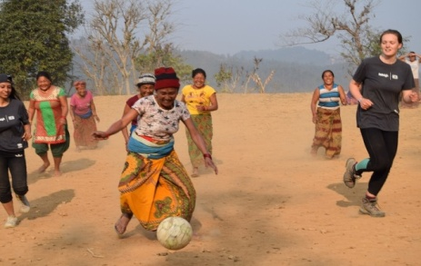  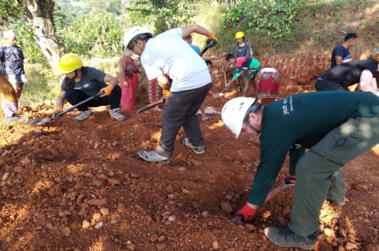  - Food security & livelihood: Preparation of LIP, provide technical training for production of off-seasonal & high value vegetable pro duction, provide technical training on goat rearing & poultry farming, provide training on making bio- pesticide, start up support for LIP implementation, entrepreneurship development training, support on construction of poly pond.  - Youth Leadership: Formation of youth’s group, orient on role & responsibility of youths, linkage youth network with government authority.

Name of Project | Socio-Technical Facilitation Service for Housing Reconstruction Program In Gorkha | Date from: 6 April 2018 |  | To: Till date
Name of Donor | Government of India/UNDP/ODRC | Contact Person: | Mr. Ram Sapkota
Description | Working Area: Arughat Rural Municipality, Dharche Rural Municipality, Shahid Lakhan Rural Municipality, Gandaki Rural Municipality and Gorkha Municipality of Gorkha district.  Activities Coverage:  The following illustrates the short description of project activities:  1. Household Survey  2. Reconstruction Status survey  3. Socio Technical Facilitation for Housing Reconstruction  4. Door to door Assistance  5. Support for tranche release  6. Awareness program  7. Coordination with stakeholders  8. constriction support to low cost privet shelters  9. Refresher training to mason
Name of Project | Hariyo Ban Program | Date from: November 2018 |  | To: June 2019
Name of Donor | USAID/(WWF Nepal) | Contact Person: | Mr. Purna Bahadur Kunwar
Description | Working Area: Palungtar Municipality, Siranchok RM, Ajirkot RM, Barpak Sulikot RM  Activities Coverage:  The following illustrates the short description of project activities:  1. awareness raising on Climate change  2. protection of endangered wild animal  3. support on eco tourism(Home stay promotion)  4. Conduct Income generating activities  5. support Cooperative to manage revolving fund  6. Coordination with stakeholders  7. anti-pouching committee mobilization

Name of Project | Purnima COVID-19 WASH Response Initiative Program | Date from: July 10-2020 |  | To: October 10 - 2020
Name of Donor | CARE, Mott Macdonald, UKAID | Contact Person: | Mr. Madhav Dhakal
Description | Working Area: Siranchok RM, Ajirkot RM, Chum Nubri RM, Gandaki RM, Shahid Lakhan RM and Dharche RM Gorkha  Activities Coverage:  The following illustrates the short description of project activities:  Provide Safe Water and Sanitation facilitation, Hygiene Kits, Disinfection Kits, Cleaning Materials, Sami Permanent Bathing Spaces and Toilets, Training and awareness program with Flex, Poster, Guideline in Municipalities, Wards, Quarantines, Isolations and Health Facilities.

Name of Project | COVID- 19 Response Program in Gorkha | Date from: May 1 -2020 |  | To: September -30- 2020
Name of Donor | CRS | Contact Person: | Rajesh Sunuwar
Description | Working Area: Shahid Lakhan RM, Arughat RM and Gorkha MunicipalityGorkha  Activities Coverage:  The following illustrates the short description of project activities:  Provide Safe Water and Sanitation facilitation( Contact Less Foot Operated Hand Washing Station), Hygiene Kits, Disinfection Kits, Cleaning Materials, Food support for Vulnerable and COVID affected Household)Training and awareness program with Flex, Poster, Guideline in Municipalities, Wards, Quarantines, Isolations and Health Facilities.

5. Human Resource
SN | Name of Staff | Position
1 | Sita Ram Shrestha | Executive Director
2 | Dronacharya Timalsina | Program Manager
3 | Sanod Shrestha | Program Manager
4 | Parmila Adhikari | Finance Coordinator
5 | Narayan Dhakal | Admin & Documentation Officer
6 | Nina Kumari Shrestha | Admin & HR Officer
7 | Devi Kumari Neupane | MEAL Officer
8 | Shashi Kiran Sapkota | MEAL Officer
9 | Uttam Timilsina | Program Coordinator
10 | Lok Kumari Thapa Magar | Social Mobilizer
11 | Urmila Timilsina | Marketing Officer
12 | Sarswati Lama | Artisan Facilitator
13 | Chakra Pani Joshi | Engineer
14 | Santosh Adhikari | Junior engineer
15 | Sndeep Ghimire | Junior engineer
16 | Sostika Pokharel | Admin & Finance Officer
17 | Kamal Bdr Bohora | Overseer
18 | Bikash Shrestha | Community Technician Sub overseer
19 | Sangita Subedi | Project Officer
20 | Lila Dhar Pant | Agri. Technician
21 | Bishal Bista | Agri. Technician
22 | Amrita Gurung | Agri. Technician
23 | Bijaya B.C | Agri. Technician
24 | Muna Kadel Ghimire | Agri. Technician
25 | Kamal Pokharel | Social Mobilizer
26 | Asal Kattel | Program Coordinator
27 | Gopal Devkota | Junior Technical Assistant
28 | Ramesh Budhathoki | Overseer
29 | Ram Kumar Shrestha | Junior Technical Assistant
30 | Binod Khanal | Junior Technical Assistant
31 | Bikram Tamang | Program Coordinator
32 | Prativa Shrestha | Finance Officer
33 | Ujjwal Wagle | Health Officer
34 | Jit Bahadur Budha | Overseer
35 | Uttam Pokharel | Sub-Overseer
36 | Kamala Gurung | Social Mobilizer
37 | Sobita Karki | Social Mobilizer
38 | Swikiriti Gurung | Social Mobilizer
39 | Ash Man Gurung | Social Mobilizer
40 | Gham Rani Ghale | Social Mobilizer
41 | Ram Maya Thapa | Social Mobilizer
42 | Samjhana Ghimire | RH Assistant
43 | Kristina Bogati | RH Assistant
44 | Anita Bhandari | RH Assistant
45 | Bikas Dhungana | Program Officer
46 | Bimala Gurung | Social Mobilizer
47 | Abjal Miya | Social Mobilizer
48 | Raj Kumar Gurung | Social Mobilizer
49 | Rachana Baniya | Social Mobilizer
50 | Sunita Shrestha | Social Mobilizer
51 | Bhim Kumari Ghale | Social Mobilizer
52 | Raju Bhatta | Social Mobilizer
53 | Narayan Dhakal | Social Mobilizer
54 | Bhagwaati Lamichhane | Social Mobilizer
55 | Niru Gurung | Social Mobilizer
56 | Minu Roka | Social Mobilizer
57 | Arjun Gandarbha | Social Mobilizer
58 | Yam Maya Rana | Office Assistant
59 | Rishi Shrestha | Procurement & Logistic Officer
60 | Santosh Shrestha | Finance Assistant
61 | Rabin Kattel | Shelter Coordinator
62 | Sanjita Shrestha | WASH Coordinator
63 | Sila Amgain | Office Assistant
64 | Resham Lal Shrestha | Social Mobilizer
65 | Santosh Pandey | Social Mobilizer
66 | Yukta Bir Tamang | Technical Assistant (Overseer)
67 | Sagar Khadka | Social Mobilizer
68 | Suraj Lamichhane | Social Mobilizer
69 | Rupesh Rijal | Social Mobilizer
70 | Som Prasad Gurung | Social Mobilizer
71 | Sunil Shrestha | Technician (Sub Overseer)
72 | Kul Bahadur Thapa | Technician (Sub Overseer)
73 | Prem Gurung | Technician (Sub Overseer)
74 | Bigyan Regmi | Technician (Sub Overseer)
75 | Ishwori Bhatta | Social Animator
76 | Rupa Rana Magar | Social Animator
77 | Kopila Tamang | Social Animator
78 | Susmita Khadka | Social Animator
79 | Jit Man Gurung | Social Animator
80 | Sujan Gurung | Social Animator
81 | Sita Dahal | Social Animator
82 | Sajan Rana Magar | Social Animator
83 | Sunita Amatya | Social Animator
84 | Madan Gurung | Social Animator
85 | Saroj Gurung | JTA
86 | Sarmila Sunar | Social Animator
87 | Anita Gurung | Social Animator
88 | Bal Krishna Pariyar | Social Animator
89 | Devi Prasad Lamichhane | JTA
90 | Yam Bahadur Gurung | JTA
91 | Saroj Rana | Driver
92 | Saroj Pariyar | Mason/Technician
93 | Amish Ghimire | Mason/Technician
94 | Lokesh Tamang | Mason/Technician
95 | Suraj Chandra Thapa | Mason/Technician
96 | Ramesh Budhathoki | Mason/Technician
97 | Raj Bd Buda | Mason/Technician
98 | Dil Prasad Gurung | Technician
99 | Ful Maya Dawadi | Technician
100 | Puranjan Sapkota | Program Coordinator
101 | Surendra Ghimire | Program Officer
102 | Santosh Bashyal | Admin Finance Officer
103 | Kishor Pokharel | Junior Technical Assistant
104 | Kusum Bhatta | Junior Technical Assistant
105 | Som Kumar Magar | Field Officer
106 | Santosh Syantang | Field Officer
107 | Bandana Parajuli | Admin and Finance Officer
108 | Birendra Shrestha | Engineer
109 | Supreme Sapkota | Engineer
110 | Raju Adhikari | Engineer
111 | Sanjay koirala | Engineer
112 | Rabin Pokherel | Engineer
113 | Anjan Shrestha | Engineer
114 | Binod Bikram Shah | Engineer
115 | Sudarshan Kandel | Sub - Engineer
116 | Shankar Khadka | Sub - Engineer
117 | Dhurba Aryal | Sub - Engineer
118 | Dipak Raj Joshi | Sub - Engineer
119 | Uttam Baniya | Sub - Engineer
120 | Nirpa Raj Pandey | Sub - Engineer
121 | Sita Bayalkoti | Sub - Engineer
122 | Subodh Kattel | Sub – Engineer
123 | Regan Karki | Sub – Engineer
124 | Chandra Adhikari | Sub - Engineer
125 | Sima Khadka | Community facilitator
126 | Pabitra Rana Magar | Community facilitator
127 | Babita Gurung | Community facilitator
128 | Shanti Ghale | Community facilitator
129 | Chammeli sirmal | Community facilitator
130 | Mandira Basnet | Community facilitator
131 | Menuka Lamichhane | Community facilitator
132 | Bimal Shrestha | Community facilitator
133 | Rimka Gurung | Community facilitator
134 | Man Maya Gurung | Community facilitator
135 | Bikram Gurung | ANS
136 | Kumar Lama | ANS
137 | Laxman Lamichhane | ANS
138 | Sujan Kumar Sunar | ANS
139 | Hema Karki | ANS
140 | Krishna Bahadur Thapa Magar | ANS
141 | Dhan Bahadur Thapa | ANS
142 | Gobinda Shrestha | ANS
143 | Bir Bahadur Gurung | ANS
144 | Dil Bahadur Gharti | ANS
145 | Ram Saran Kumal | ANS
146 | Kishor Thapa Magar | ANS
147 | Amrit Bahadur Thapa | ANS
148 | Bishnu Pandey | ANS
149 | Sangita Kattel | ANS
150 | Ram Kumar Shrestha | ANS
151 | Nur Bahadur Thapa | ANS
152 | Sital Babu Kattel | ANS
153 | Medan Bahadur Khadka | ANS
154 | Dumber Bahadur Sunar | ANS
155 | Kamdin Miya | ANS
156 | Ankaj Khanal | ANS
157 | Dipak Darai | ANS
158 | Buddhi Man Tamang | ANS
159 | Ram Saran Kumal | ANS
160 | Krishna Pantha | ANS
161 | Madan Gurung | ANS
162 | Bhakta Bahadur Gurung | ANS
163 | Om Kumar Thapa Magar | ANS
164 | Udaya Bahadur Thapa Magar | ANS
165 | Ratna Bahadur Ale | ANS
166 | Resham Bahadur Rana Magar | ANS
167 | Sujan Thapa | ANS
168 | Ashis Chapang | ANS
169 | Nanda Bahadur Thapa | ANS
170 | Sanjog Thapa Magar | ANS
171 | Prabin Gurung | ANS
172 | Aash Bahadur Gurung | ANS
173 | Santosh Gurung | ANS
174 | Sushila Gurung | ANS
175 | Khadga Gurung | ANS
176 | Siring Gurung | ANS

6. Assets:
S.N. | ITEM DESCRIPTION | QTY | S.N. | ITEM DESCRIPTION | QTY
1 | Laptop Computer | 56 | 19 | Office T-Table | 6
2 | Office Chair | 50 | 20 | Desktop Computer | 4
3 | Plastic Chair | 33 | 21 | External Hard Disk | 4
4 | Meeting Chair | 32 | 22 | Projector | 4
5 | Cupboard | 28 | 23 | Avini Level | 3
6 | Mobile Phone | 25 | 24 | Scanner | 2
7 | Wooden Table | 23 | 25 | Computer Table | 1
8 | Steel Open Rack | 23 | 26 | Generator | 1
9 | Office Table | 18 | 27 | GPS | 1
10 | Camera | 17 | 28 | Invertor | 1
11 | Celling Fan | 16 | 29 | Projector Screen | 1
12 | Printer | 15 | 30 | Scorpio Pick Up | 1
13 | Meeting Table | 11 | 31 | Scooter | 1
14 | Wooden File Rack | 10 | 32 | Sofa set | 1
15 | Power Bank | 10 | 33 | Stand-Fan | 1
16 | Motorbike | 9 | 34 | Steel Glass Rack | 1
17 | Steel Table | 8 | 35 | Water Dispenser | 1
18 | Visitor Chair | 6

‘Thank you’

